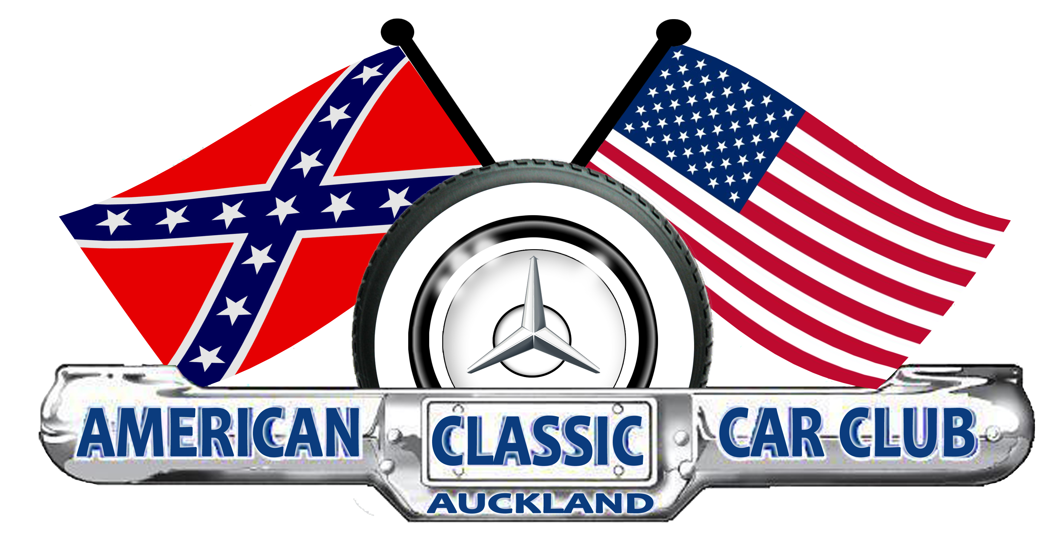

ACCCA Club Apparel Order

Ordered by :-
(please clearly print name and delivery address)

Please mail your order to Sew Hot Monograms, PO Box 4478, Mt. Maunganui 3149 along with your cheque, or scan and email
order to sewhot@xtra.co.nz and prepay to bank acc #: 06-0379-0235700-00 using name as reference.

Triton polo Shirt – P225MS male $45 |  | S | M | L | XL | 2XL | 3XL | 5XL
Garment half chest cm |  | 52 | 55 | 58 | 62 | 65 | 71 | 79
Qty.
Triton polo Shirt – P225LS female $45 |  | 8 | 10 | 12 | 14 | 16 | 18 | 20 | 22 | 24
Garment half chest cm |  | 46.5 | 49 | 51.5 | 54 | 56.5 | 59 | 62 | 65 | 68
Qty.
Headwear 4236 flame cap $28 Qty.
Order Total | Polos @ $45 = | Caps @ $28 = |  |  | Order total $ |  |  | Cheque or Direct Credit (circle which)
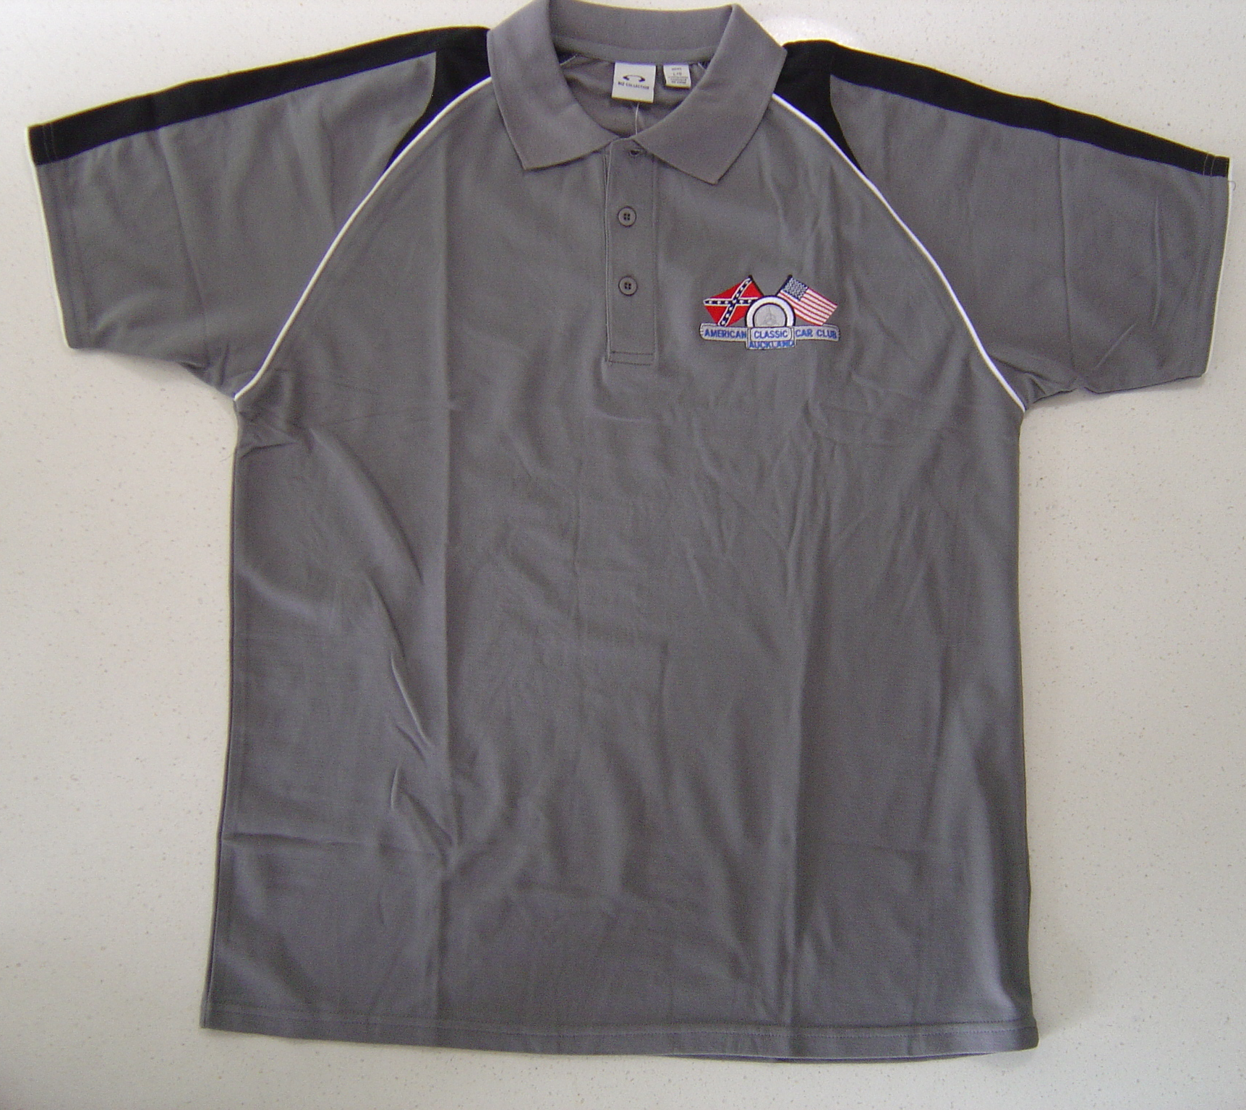
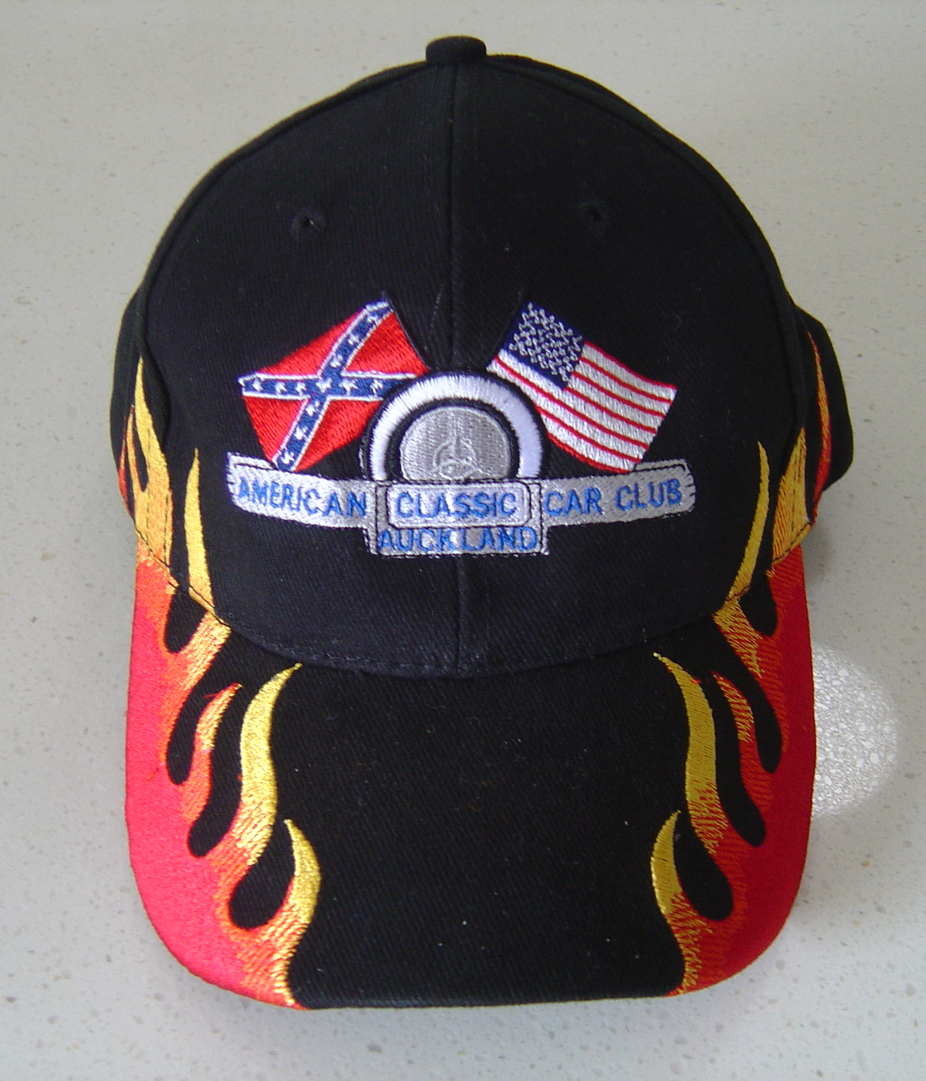
Stylish mens and ladies polos with a 50% cotton inner/50% polyester outer, raglan sleeve and white piping trim cuff, in grey with black contrasting shoulder panels and matching knitted collar.
The material is a breathable performance fabric utilizing a unique moisture wicking technology, which allows maximum airflow to maintain comfort, whilst allowing rapid evaporation of moisture through the fibres.
The best way to determine the size you require is to take an existing polo that fits you nicely, lay it flat and measure the front from armpit to armpit, then make the best match from the “Garment half chest” measurement on the order form.

